|  |  |
| --- | --- |
| A picture of a winding road and trees  website project proposal  Research and planning | ST10481788  chaante lee sybil pillay  Web development (introduction) WEDE5020 |

Table of Contents

SPCA proposal 2

Gift of the giver’s proposal 3

Website structure/ site map 4

Homepage 4

About us 5

Services 5

Enquiries 6

contact us 6

References 7

# SPCA proposal

For the SPCA (society for the prevention of cruelty to animals), It's a non-profit animal welfare organization dedicated to protecting and improving the lives of animals. SPCAs operate around the world, with the oldest being the Royal Society for the Prevention of Cruelty to Animals (RSPCA) in England. In South Africa, the NSPCA (National Council of SPCAs) governs the various SPCAs around the country. The website could be designed in a way that lets people of all ages interact. From school kids to university students as well as adults who want to learn more about donating and the purpose behind the SPCA. There will be a homepage which will be the main page then an about us page link with information on the organization, contact page with the numbers and services link. There could be an image of a map showing the different SPCA branches and dates and images of events that are going to happen soon and show locations where people can drop off donations like animal food, blankets, and toys. For the younger kids there could be a colourful and informative little article for them to learn about animal abuse and how to care for their pets and to respect animals. There should also be a link where people can report animal abuse and let it be anonymous. There can be links to educational YouTube videos that tell people about what is happening around the country with animals and what they can do to help. There can also be links to show people where and when they can go to a site clean-up and help around, links to fundraising events and even links to people who are interested in working for the SPCA and any job opportunities involving animals. The colour scheme will be dark blue and white. There should be colourful pictures and bold writing for the kids and for the older audience there should be educational pictures of abused animals that will grab their attention into viewing the page. Most importantly the website should be easy to navigate with clear descriptions. Languages used will be HTML, JavaScript and CSS. Timeline, by 18 August the research will be done and by 27 August the website will be done as well as GitHub repositories. Budget, this NGO website including home, about, services or products, and contact pages you might expect to pay between R6,000 to R16,000 on average. Monthly costs range between R900 to 5000 or more. In most cases where no major website maintenance is required, you will normally only pay R2400 pm (Incl VAT) for SEO, website script updates, content updates and website speed and mobile optimisations.

## 

## Gift of the giver’s proposal

for the gift of the givers who are a South African disaster relief and humanitarian aid organization. It's the largest of its kind on the African continent, founded in 1992 by Dr. Imtiaz Sooliman. The organization provides a wide range of assistance, including disaster response, hunger alleviation, water provision, healthcare, and education. They were one of the biggest helpers for essential supplies during the COVID-19 pandemic. The website can be designed in a way where people can see and share what’s going on around the world and where people right now need help the most. A place where people can see real time and recent updates where this organization is making a difference and what they can do to help. There will be a homepage, which will be the main page and will have links to the about us page and contact page and services page. There should be a paragraph explaining and informing donors and potential donors about ongoing missions. There should be a donation section filled with different links for different missions which people are interested in helping. There should be an educational piece of writing for school kids to educate them on the less fortunate and how they can help or convince people to help and maybe for university kids to learn how to design a campaign to gain attention to help people and raise awareness on what’s happening around them. This website should act as a storytelling tool that informs donors and supporters on what's happening in missions around the world. It should emphasize on the main problems around the world right now like the genocide that’s happening in Gaza and Congo and help gain awareness. There should be contact numbers and emails of the foundation linked on the websites contact page link. Even make an anonymous page where people talk about what’s going on and how they can help. There should also be a link to click on if someone wants to work for the gift of the giver’s organization which will be the services page. The design of the page should be global images, bold capitalized writing and inspiring images that tug on the heart strings of people to donate. Languages used will be HTML, JavaScript and CSS. Timeline, by 18 August the research will be done and by 27 August the website will be done as well as GitHub repositories. Budget, this NGO website including home, about, services or products, and contact pages, you might expect to pay between R6,000 to R16,000 on average. Monthly costs range between R900 to 5000 or more. In most cases where no major website maintenance is required, you will normally only pay R2400 pm (Incl VAT) for SEO, website script updates, content updates and website speed and mobile optimisations.

### Website structure/ site map

This is the overall structure of my website I have chosen the SPCA proposal.

1. Homepage
2. About us
3. Services
4. Enquiries
5. Contact us

# Homepage

* Logo
* Slogan
* Navigation menu ,Links to the rest of the pages (about us, contact us, ect)
* Photo

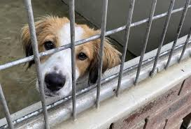

* Summary of main activities of the organisation
* Contact info
* Copyright/ year

## About us

* Logo
* Slogan
* Links to the rest of the pages
* Description of website and information on the organization

* Contact info
* Copyright/ year

## Services

* Logo
* Slogan
* Links to the rest of the pages
* Information on the services of organization and how to get involved

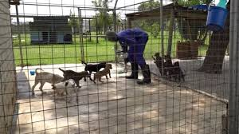

* contact info
* copyright / year

### Enquiries

* logo
* slogan
* comment space for people to enquire anonymously
* information on donations and sponsorships

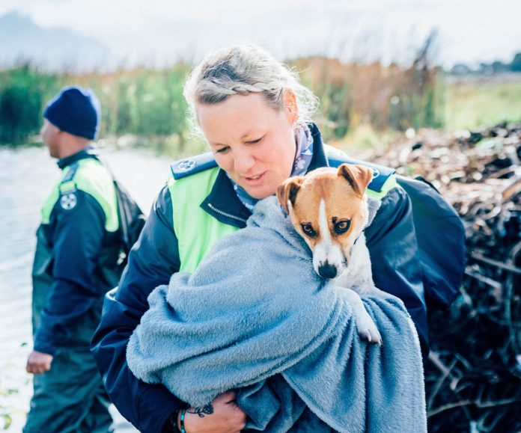

* contact info
* copyright/ year

### contact us

* logo
* slogan
* contact emails and numbers

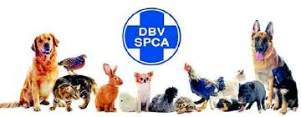

* copyright/year

### References

• About NSPCA | Animal welfare protection non-profit organization

• Cape of Good Hope SPCA – animal cruelty must stop

• Covid-19 intervention – south Africa – gift of the giver’s foundation

* SPCA
* The old mutual gift of the giver’s life fund
* New perspective studio- what is the cost of creating a website in south Africa
* Website web designs- website maintenance what are the costs of website maintenance